# **19/09/2022**

**Company organization:**

CEO->Chief Executive Officer( AE), director ejecutivo

MD-> Managing Director (BE), director general

Employees-> staff -> workers

Employer, empleador-> the boss, el jefe

to run out company-> the MD runs the company

to deal with customers, tratar

to manage/head a department

R&D-> Research and Development (I+D) →investigación y desarrollo

Human Resources (HR)

IT→ Information technology

Customer Service→ servicio al cliente



# **22/09/2022**

**Puestos**

* Helpdesk technician→ I’m responsible for solving IT problems over the phone. I usually work as part of a team.

**VS**

* Support technician→ Our company provides basic support for our clients and tests new software products on the market.
* Test computer hardware

**Acciones**

* Solve problems
* Operate machine
* Design a webpage
* Give support
* Input data
* Check connections

**PRESENT SIMPLE**

**DO/DOES**

**he/she/it +s/es/ies (study=>studies)**

1. **True facts**
   1. Toyota produces cars
2. **Habits and routines**
   1. I check my emails twice a day
3. **Permanent situations:** 
   1. I live in a flat!
4. **Future Schedules (timetables):** 
   1. The train leaves at 5pm
5. **Sports commentary, reviews and narration**
6. **Future in time clauses**
   1. I won't go out until it stops raining.

* **MOST FREQUENTLY USED EXPRESSIONS:** always, usually, in the morning/afternoon (tarde)/evening (noche), every day/week, at night, the weekends.
* **SPELLING RULES FOR THE SIMPLE PRESENT TENSE**

**a) Add –s for most verbs**

work - works, buy - buys, ride - rides, return - returns

**b) Add –es for words that end in –ch, -s , -sh, -x, or –z.**

watch - watches, pass - passes, rush - rushes, relax - relaxes, buzz - buzzes

**c) Change the –y to –i and add –es when the base form ends in a consonant +y.**

study - studies, hurry - hurries, dry - dries

**\*Do not change the –y when the base form ends in a vowel +y.**

**Add –s:**

play - plays, enjoy - enjoys

**d) A few verbs have irregular forms.**

be - is, do - does, go- goes, have - has

**PRESENT CONTINUOUS**

**TO BE + ING**

1. **Actions happening now**
   1. He is calling an ambulance at the moment
2. **Actions developing / changing**
   1. Traffic becoming heavier
3. **Temporary situations**
   1. I am living with my parents until I find my own flat
4. **Future managements (planes)**
   1. We are leaving for NY tomorrow morning!

* **MOST FREQUENTLY USED EXPRESSIONS:** now, at the moment, these days, at present, today, tonight, nowadays,

currently (actualmente)

*FALSE FRIEND: Actually -> En realidad, de hecho

* **SPELLING RULES FOR THE PRESENT CONTINUOUS**

**a) Add –ing to the base form of the verb.**

read - reading, stand - standing, jump - jumping

**b) If a verb ends in a silent –e, drop the final -e and add –ing.**

leave - leaving, take - taking, receive - receiving

**c) In a one-syllable word, if the last three letters are consonant-vowel-consonant combination (CVC), double the last consonant before adding –ing.**

sit - sitting, run - running, hop - hopping

**\*However, do not double the last consonant in word that end in w, x, or y:**

sew - sewing, fix - fixing, enjoy - enjoying

**d) In words of two or more syllables that end in a consonant-vowel-consonant combination, double the last consonant only if the last syllable is stressed (acentuada/tónica).**

admit - admitting, regret - regretting

**e) If a verb ends in –ie, change the –ie to y before adding -ing.**

die - dying

* **EXCEPCIONES PS VS PC:**
  + She owns (dueño/en propiedad) a company at the moment
  + ¿Pq no se pone el continuo? Es un verbo estático (no de movimiento)
  + He seems very tired now
  + ¿Pq no se pone el continuo? Es un verbo estático (no de movimiento)

**QUESTION WORDS**

* Who -> quién (person)
* Where -> dónde (place)
* Why -> por qué
* When -> cuándo (time)
* How -> cómo (manner)
* What -> qué (object/idea)
* Which -> cuál (choice)
* Whose -> de quién (possession)
* What kind -> que tipo
* How much -> cuánto
* How many -> cuántos
* How long -> durante cuánto tiempo
* How often -> con qué frecuencia
* How far -> a qué distancia
* How old -> cuántos años
* How come -> cómo es que

**QUESTION FORMATION**

1. She works in NY -> Where does she work?

QU A S I (verb)

I->infinitive

QU->question

A->auxiliar-> Do//Does: he, she, it (verb infinitive)

S->sujeto

1. Susan works in Ny -> Who works in NY? ->¿PQ NO LLEVA AUXILIAR (DOES)?-> porque Susan es Sujeto y Who lo sustituye.

[Question forms | LearnEnglish](https://learnenglish.britishcouncil.org/grammar/a1-a2-grammar/question-forms)

[Form questions - Ask for the underlined part](https://www.englisch-hilfen.de/en/exercises/questions/form.htm)

* Examples in past:

The students began the class at 8.

1. Who began the class at 8?
2. What did the students begin? ->infinitive verb
3. When did the students begin the class? ->infinitive verb

(Paul’s brother) gave me a present.

1. Who gave me a present?
2. Whose brother gave me a present?
3. Who did Paul’s brother give a present? ->infinitive verb
4. What did Paul’s brother give to me? ->infinitive verb

(David’s children) found a £20 note in the street yesterday.

1. Who found a £20 note in the street yesterday?
2. Whose children found a £20 note in the street yesterday?
3. What did they find in the street yesterday?
4. Where did they find a £20 note yesterday?
5. When did they find a £20 note in the street?
6. ¿Yes-NO?-> Did David’s children find a £20 note in the street yesterday?

* Exercise, write questions for the underlined words *(entra en examen)**[EXAM]**:
  + He works **on** the second floor -> **On** which floor does he work? -> Which floor does he work **on**?
  + They drive to work twice a week -> **How often** do they drive to work?
  + Thigrtas is my laptop -> **Whose laptop** is this?
  + My dad likes the blue jacket best -> **Which** jacket does your father like **best**?
  + They usually travel by plane -> In which transport do they travel? -> + en inglés -> **How** do they usually travel?

**PREPOSITIONS OF TIME (para decir cuando sucede algo) / PREPOSITIONS OF LOCATION**

* IN (períodos largos)
  + expresiones (in the morning)
  + meses (in July)
  + estaciones (in spring)
  + años (in 2003)
  + siglos (in the 19th century)
* ON (días específicos)
  + días (on Saturday)
  + fechas (on 21st May)
  + parte específica del día (on Saturday evening)
  + adj + day (on a hot day)
* AT (horarios y eventos especiales)
  + feriados (at New Year)
  + tiempo (at 4 o’clock)
  + vacaciones
  + expresiones (at the moment)
* EXCEPCIONES
  + at night
  + at the weekend -> UK
  + on the weekend - USA

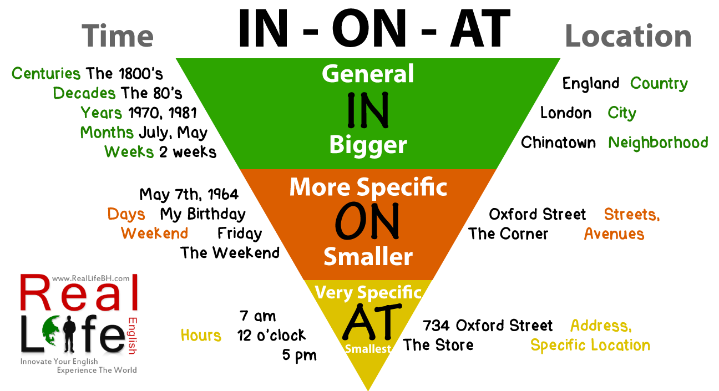

**PREPOSITIONS OF PLACE**

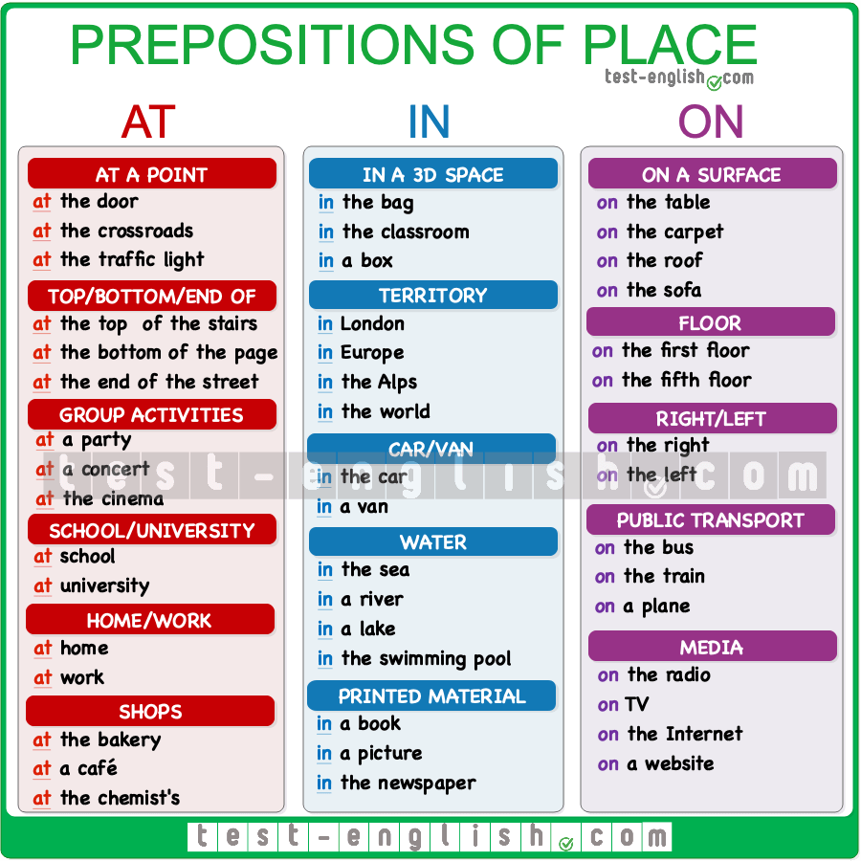

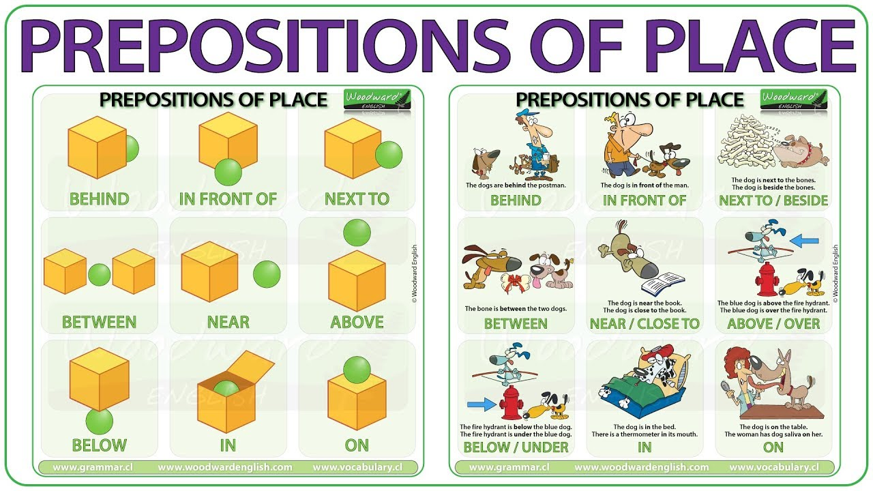

**ADVERBS OF FREQUENCY**

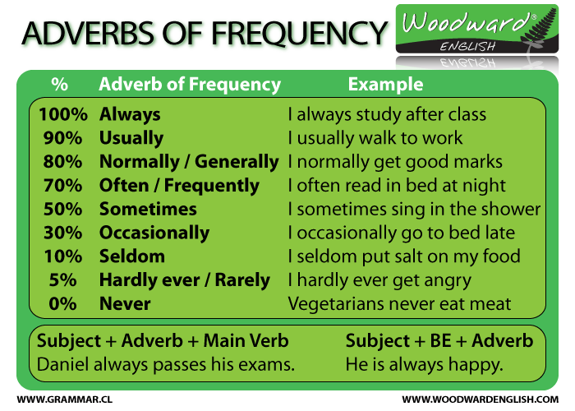

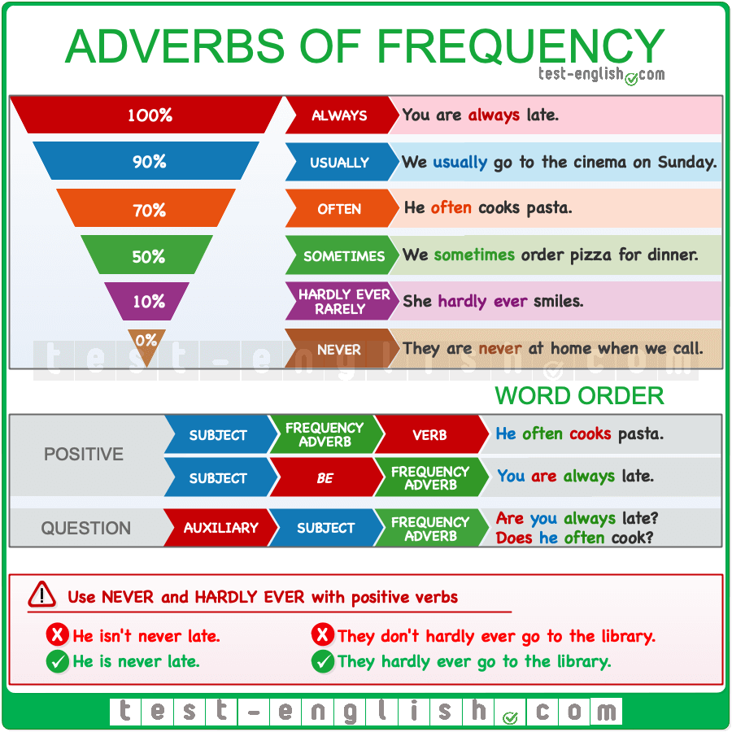

**ANOTHER-OTHER-OTHERS**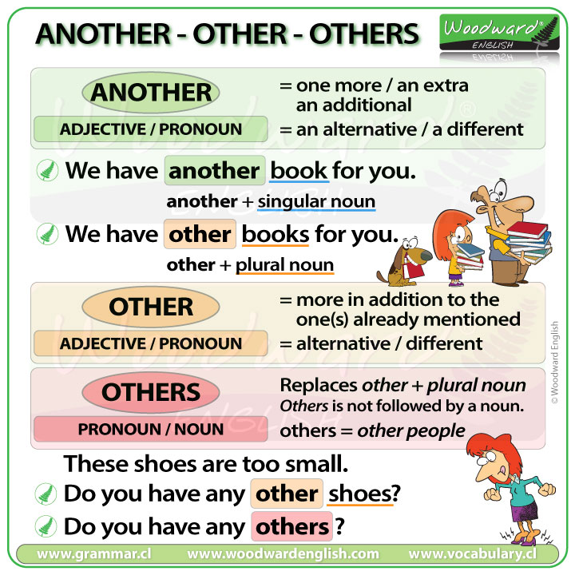

**PHRASAL VERBS**

[*20 Super Common Phrasal Verbs — Dynamic English | Clases Particulares de Inglés*](https://www.dynamicenglish.cl/blog-feed/phrasal-verbs)

* **GET**

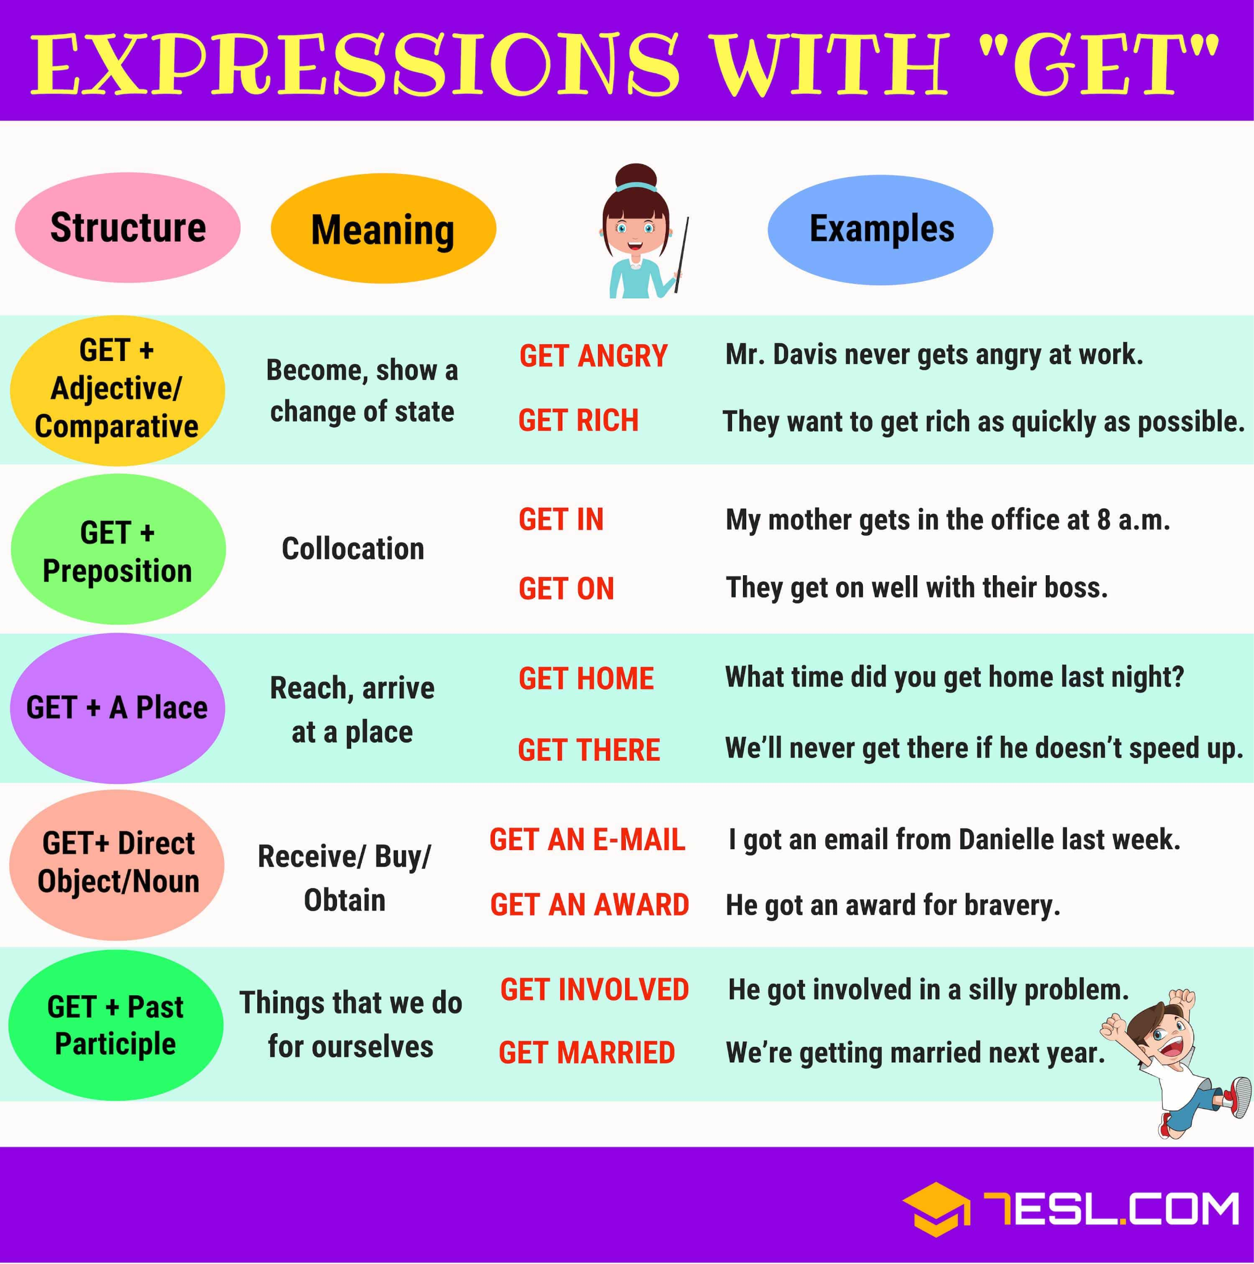

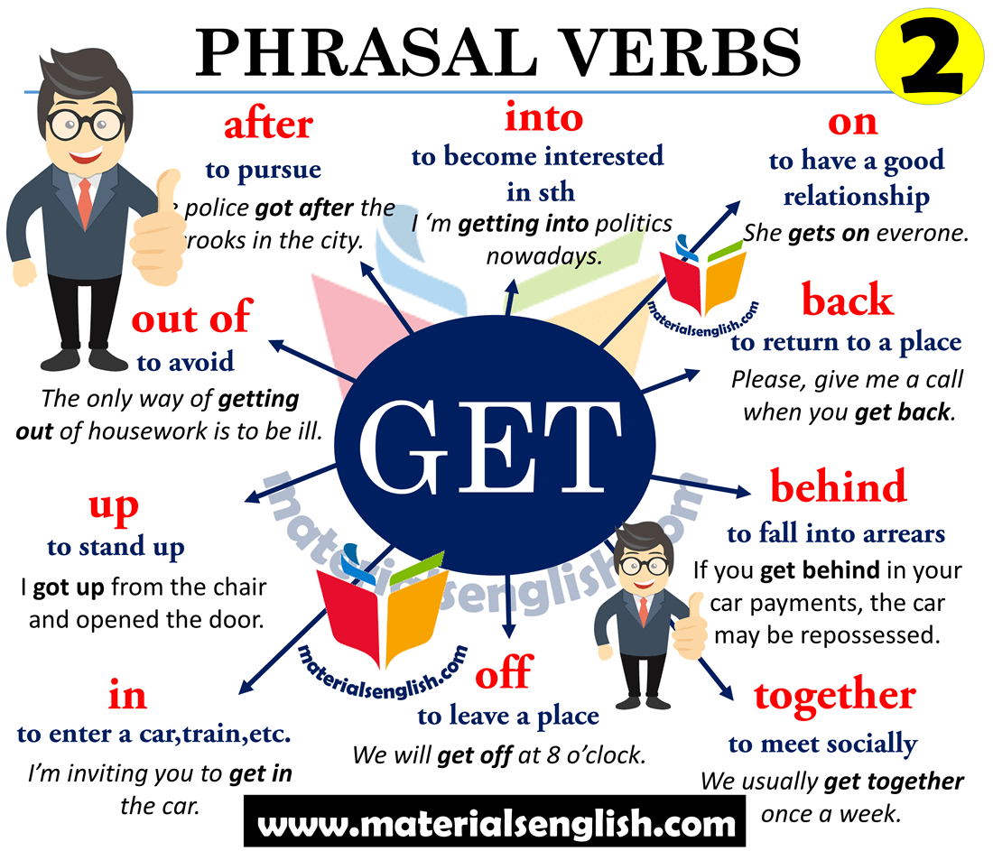

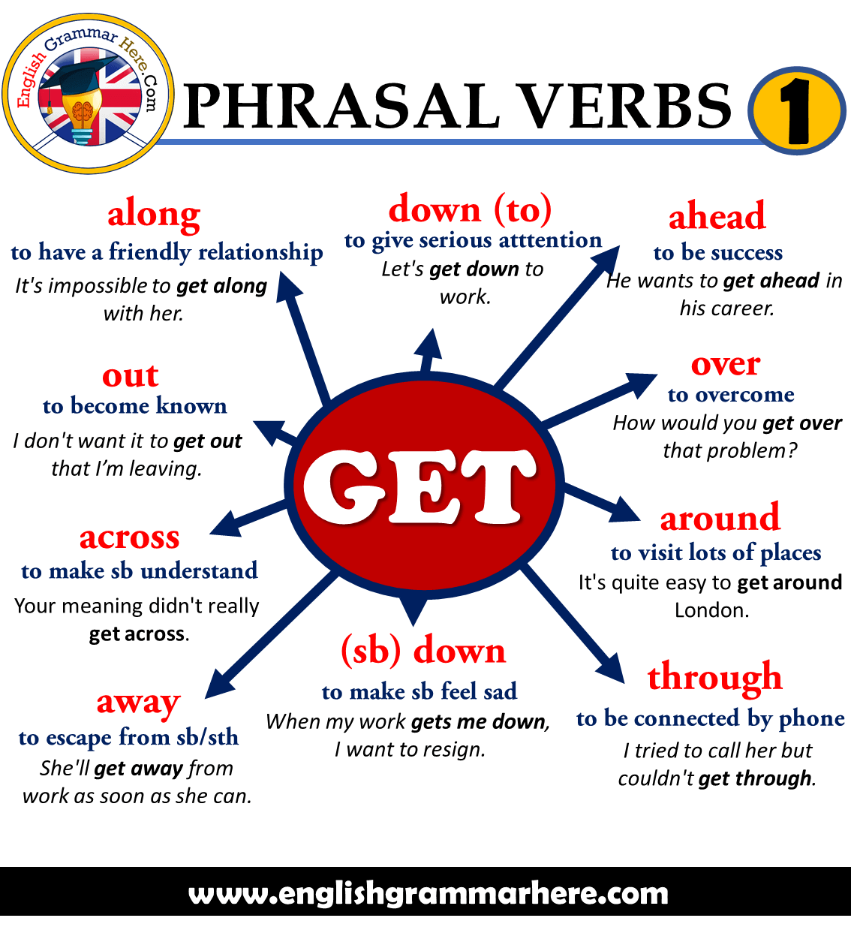

**PAST SIMPLE**

**2º COLUMN OF IRREGULAR VERBS**

* **I watched TV**
* **I didn’t watched TV**

**? Did you watch TV?**

1. **Finished time word**
   1. I went to the cinema yesterday.
2. **Finished time period**
   1. Leonardo painted the Mona Lisa.
3. **Details of news (Use with: Present Perfect)**
   1. I’ve hurt my leg. I fell off a ladder.
4. **Actions in stories (Use with: Past Continuous)**
   1. He sat down and ordered a coffee.
5. **Present/Future-> Unreal/Imaginary things**
   1. If I won the lottery, I would buy a house.
   2. **Use with: wish, it’s time, second conditional.**

* **MOST FREQUENTLY USED EXPRESSIONS:** ago, yesterday, just now, in 1995, last week/month/night…, how long ago.
* **SPELLING RULES FOR THE SIMPLE PAST TENSE OF REGULARS V.**

1. **If the verb ends in a consonant, add –ed.**

return - returned, help - helped, cook - cooked

1. **If the verb ends in –e, add –d.**

live - lived, create - created, die - died

1. **In one-syllable words, if the verb ends in a (CVC) combination, double the last consonant and add -ed.**

hop - hopped, rub - rubbed

**\*However, do not double one-syllable words ending in –w, -x, or –y.**

bow - bowed, play - played, mix - mixed

1. **In words of two or more syllables that end in (CVC) combination, double the last consonant only if the last syllable is stressed.**

prefer - preferred (the last syllable is stressed.) visit - visited (the last

syllable isn’t stressed)

1. **If the verb ends in a consonant, + y, change the -y to -i and –ed.**

worry - worried, copy - copied

1. **If the verb ends in a vowel +y, add -ed. (Do not change the –y to –i.)**

play - played, annoy - annoyed

**\*Exception: pay - paid, lay - laid, say - said**

**PRESENT PERFECT**

**HAVE/HAS + PAST PARTICIPLE (3ª column irregular verbs)**

1. **How long (unfinished)**
   1. I’ve known Karen since 2003.
   2. She’s lived in London for 3 years.
   3. **Use with: since (point in the past), for (duration).**
2. **Unfinished time word (finished)**
   1. I haven’t seen her this month.
   2. **Use with: this**
3. **Present result (finished)**
   1. I’ve lost my keys **(so I can’t get into my house).**
   2. He is very happy. He has won a race.
4. **News/Recent events (finished)**
   1. The Queen has died.
   2. **Use with:**
   3. **Just:**acción que acaba de ocurrir.
      1. **Past Perfect:** They **have + *just* + arrived. (acabar de)**
      2. **Present:** She finished studying *just now.*
   4. **Yet:** algo que esperábamos que sucediera, pero todavía no ha pasado.
      1. **Preguntas:** Have they arrived yet? **(aún, ya)**
      2. **Negaciones:** I haven't seen it *yet*.
   5. **Still (todavía, aún):** acciones que esperábamos que ya hubieran ocurrido.
      1. **Antes del verbo (Negativa):** He *still* hasn't replied.
      2. **Después del verbo:** She can *still* dance well.
   6. **Recently/Lately**
   7. **Already (ya).** Expresar la realización de una acción que implícitamente estaba en una lista de pendientes. En posición media o final.
      1. **Afirmación positiva:** I **have + *already* + seen** that film.
      2. **Preguntas:** Have you got dressed *already*?

[*'still' and 'no longer', 'already' and 'yet' | LearnEnglish*](https://learnenglish.britishcouncil.org/grammar/english-grammar-reference/still-and-no-longer-already-and-yet)

[*¿Cuándo usar yet, already, just & still en el present perfect? ⋆ Speakingo ⋆*](https://speakingo.com/es/still-yet-already-just-present-perfect-ingles/)

1. **Life experience / Personal change (finished)**
   1. I’ve been to Tokyo.
   2. **Use with: ever, never.**
   3. **So far: hasta ahora, hasta el momento , hasta la fecha**

**ALSO/TOO/AS WELL-> también**

I **also** like pasta.

I like pasta **too.**

He likes pasta **as well**. (es más informal que TOO y ALSO)

**EITHER-> o bien, cualquiera /NEITHER-> ni, tampoco**

[***Using either/or and neither/nor in English (with examples)***](https://preply.com/en/blog/using-either-neither-nor-and-or-in-english/)

**TRADUCCIONES ODIOSAS**

-Llevan casados 10 años-> They have been married for ten years

-Empezaron a trabajar hace dos mes-> They started working ~~since~~ two months ago (Past Simple, since nooo)

-Vivo en Madrid desde que tenía 5 años-> I have lived (no Present Simple, porque sigo viviendo en madrid) in Madrid since i was five years old.

**PHRASAL VERBS**

[*20 Super Common Phrasal Verbs — Dynamic English | Clases Particulares de Inglés*](https://www.dynamicenglish.cl/blog-feed/phrasal-verbs)

**SPELLING RULES -ING / -ED**

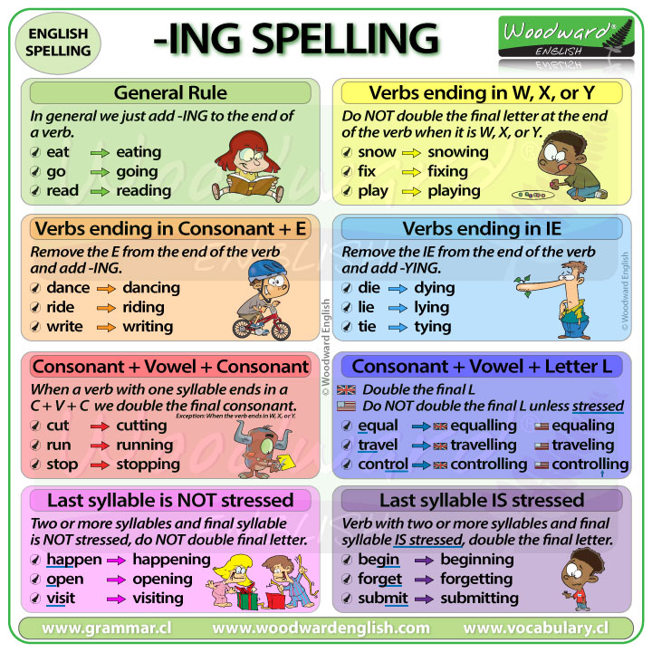

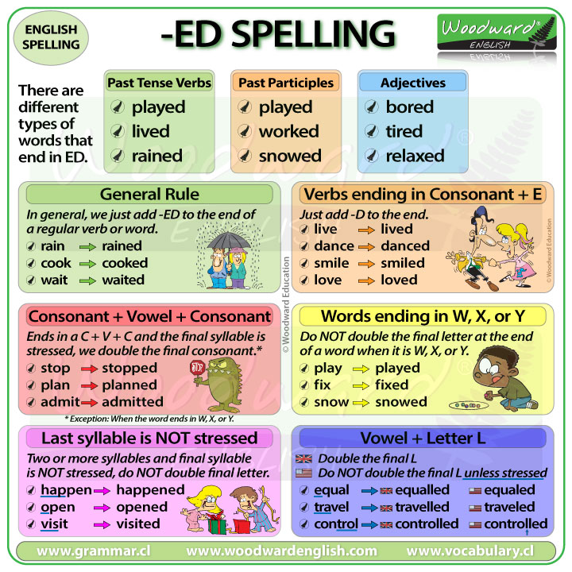

**HALLOWEEN QUESTIONS**

1. Do you like watching horror films?

Normally, scary movies make me laugh. Because it looks like humour

in the scenes they tell.

1. What's the scariest film you've ever seen?

None.

1. Are you a *scaredy-cat person?

No.

1. Which scene from The Jigsaw *scared you half to death?

**\* Vocab.**

**Scaredy-cat person=** a person who is easily frightened/scared of a lot of things

**Scare you half to death=** scare a lot

**PREGUNTAS EXAMEN PARCIAL 10 Noviembre**

* **Grammar:** Present and Past Tenses
  + 2 ejercicios
  + 1 ejercicio questions
* **Vocabulary (rellenar huecos):** 
  + company organization
  + job positions
  + parts of a computer
  + assembling a computer
* **Reading**
  + 1 ejercicio True/False
  + 1 ejercicio answer questions
* **Skills**
  + Ordenar diálogo/conversación telefónica
* **WRITING**-> EMAIL/PRESENTACION

**CURSO BÁSICO INGLÉS**

<https://www.woodwardenglish.com/course/english/>

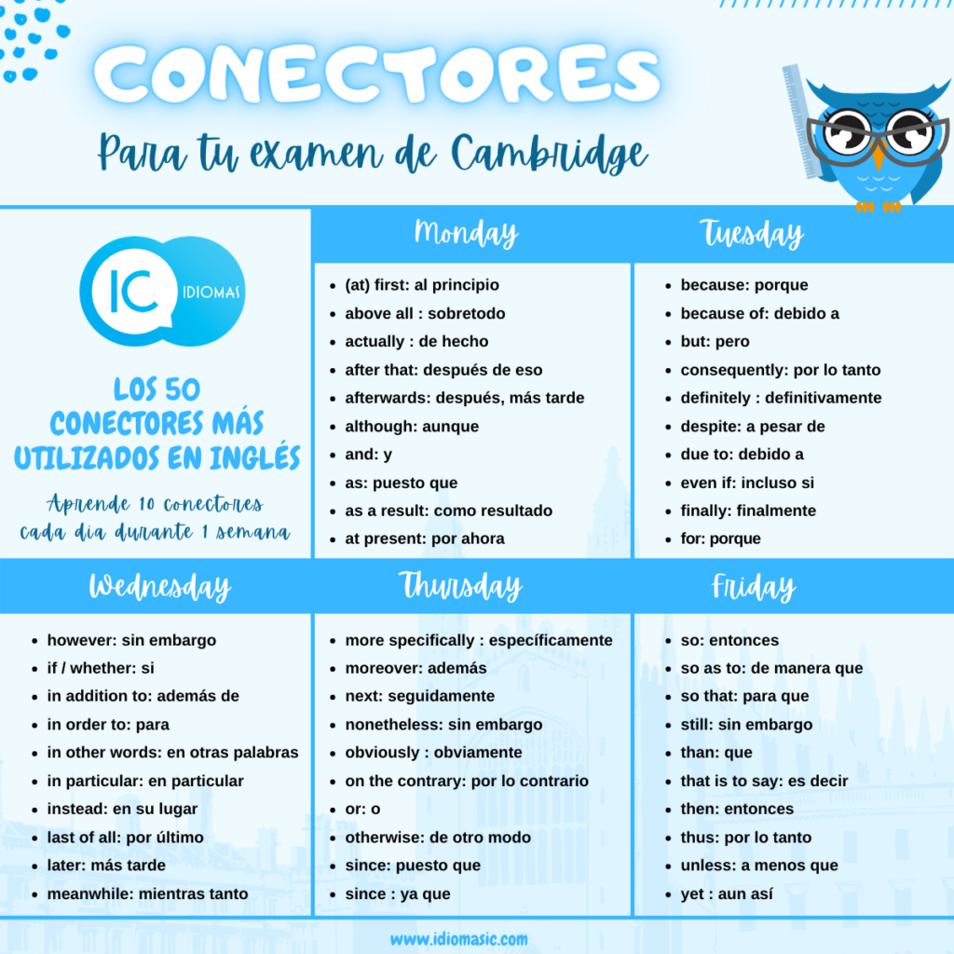

**EJEMPLOS SENCILLOS PAST QUESTIONS**

What have they read?

they have read a book

What did you write?

I wrote a book

**FUTURE TENSES**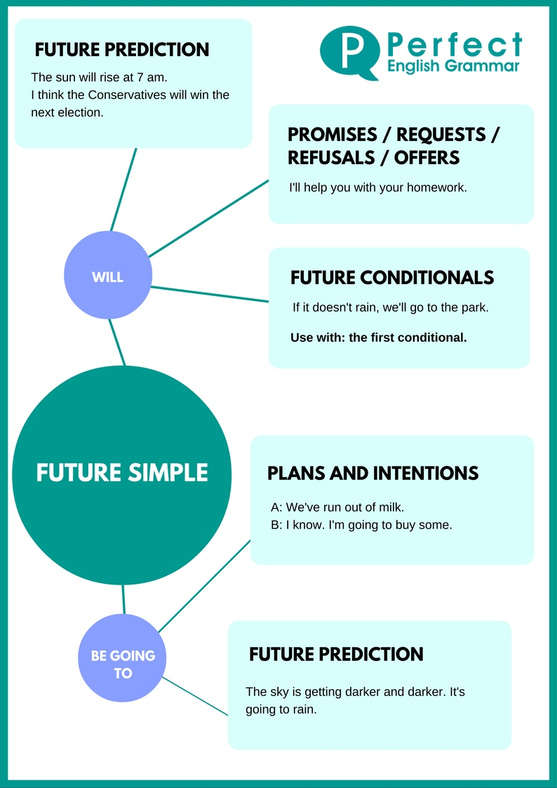

**BE GOING TO + INF**

**FUTURE SIMPLE-> WILL/WON’T**

**PRESENT SIMPLE**

**PRESENT CONTINUOUS**

**\*Uses:**

1. **Plans and intentions B**
2. **Future arrangements (fixed plans) F**
3. **Spontaneous decisions C**
4. **Timetable (Schedules) A**
5. **Promises D**
6. **Predictions based on (Evidences) E**
7. **Predictions “ “ (Opinions) G**
8. **The film starts at 5pm**
9. **Next summer I’m going to study Italian**
10. **It’s ok. I’ll call him right now!**
11. **I’ll always love you**
12. **Look at the sky! It’s going to rain**
13. **They are travelling to Dublin tomorrow**
14. **I think they’ll win the match**

**XMAS REVIEW**

**1. What do people do with their letters to Santa in the UK?**

They toss them straight in the fire. Burning the letters sends them directly to the north pole hre santa can read your christmas wishes in the smoke

**2. Where do they hang out stockings?**

Around the bed

**3. What do you normally find in crackers?**

is usually a cheesy plastic prize a paper crown and a terrible joke

**4. What causes 90% of Xmas arguments?**

**5. What’s the main Xmas dish?**

turkey with brussels sprouts

**6. What’s the main traditional Xmas dessert?**

Christmas pudding, un pastel hervido

**7. Who gives the famous Xmas speech?**

Majesty the Queen

**8. What’s the day after Xmas called in the UK?**

Boxing Day is the day after Christmas Day and falls on 26 December. It's also a public bank holiday in the UK. When 26 December is a Saturday, the Boxing Day bank holiday is moved to the next Monday.

**9. When do you need to take down the Xmas tree?**

Brits believe that the Christmas tree and decorations should be taken down within 12 days of Christmas otherwise you'll have bad luck for the rest of the year

**10. Name three of the British Xmas traditions named in the video.**

**MODALS**

**ADVICE**

1. Para dar o preguntar un consejo → **SHOULD/SHOULDN’T**

Global companies **should** never underestimate the effect that culture can have.

1. Para consejos fuertes → **MUST/MUSTN’T**

You mustn’t **invade** a British colleague’s personal space too soon.

**OBLIGATION/NECESSITY - MUST/MUSTN’T/HAVE TO**

1. Obligación viene de la persona que escribe o habla → **MUST**

We **must** show more cultural understanding.

1. Algo prohibido o no permitido → **MUSTN’T**

You **mustn’t** smoke inside any building.

1. Para mostrar que la obligación no viene de la persona que habla sino de otra persona/institución → **HAVE TO**

You **have to** get a visa to enter the country.

**LACK OF OBLIGATION/LACK OF NECESSITY**

1. **DON’T HAVE TO =** it is not necessary

You **don t have to** hurry. We have plenty of time

1. **DON’T NEED TO**